**Question 1:**

**ER Diagram Question: Traffic Flow Management System (TFMS)**

**Scenario**

You are tasked with designing an Entity-Relationship (ER) diagram for a Traffic Flow Management System (TFMS) used in a city to optimize traffic routes, manage intersections, and control traffic signals. The TFMS aims to enhance transportation efficiency by utilizing real-time data from sensors and historical traffic patterns.

The city administration has decided to implement a TFMS to address growing traffic congestion issues. The system will integrate real-time data from traffic sensors, cameras, and historical traffic patterns to provide intelligent traffic management solutions. Key functionalities include:

1. **Road Network Management**:
   * **Roads**: The city has a network of roads, each identified by a unique RoadID. Roads have attributes such as RoadName, Length (in meters), and SpeedLimit (in km/h).
2. **Intersection Control**:
   * **Intersections**: These are key points where roads meet and are crucial for traffic management. Each intersection is uniquely identified by IntersectionID and has attributes like IntersectionName and geographic Coordinates (Latitude, Longitude).
3. **Traffic Signal Management**:
   * **Traffic Signals**: Installed at intersections to regulate traffic flow. Each signal is identified by SignalID and has attributes such as SignalStatus (Green, Yellow, Red) indicating current state and Timer (countdown to next change).
4. **Real-Time Data Integration**:
   * **Traffic Data**: Real-time data collected from sensors includes TrafficDataID, Timestamp, Speed (average speed on the road), and CongestionLevel (degree of traffic congestion).
5. **Functionality Requirements**:
   * **Route Optimization**: Algorithms will be implemented to suggest optimal routes based on current traffic conditions.
   * **Traffic Signal Control**: Adaptive control algorithms will adjust signal timings dynamically based on real-time traffic flow and congestion data.
   * **Historical Analysis**: The system will store historical traffic data for analysis and planning future improvements.

**ER Diagram Design Requirements**

1. **Entities and Attributes**:
   * Clearly define entities (Roads, Intersections, Traffic Signals, Traffic Data) and their attributes based on the scenario provided.
   * Include primary keys (PK) and foreign keys (FK) where necessary to establish relationships between entities.
2. **Relationships**:
   * Illustrate relationships between entities (e.g., Roads connecting to Intersections, Intersections hosting Traffic Signals).
   * Specify cardinality (one-to-one, one-to-many, many-to-many) and optionality constraints (mandatory vs. optional relationships).
3. **Normalization Considerations**:
   * Discuss how you would ensure the ER diagram adheres to normalization principles (1NF, 2NF, 3NF) to minimize redundancy and improve data integrity.

**Tasks**

**Task 1: Entity Identification and Attributes**

Identify and list the entities relevant to the TFMS based on the scenario provided (e.g., Roads, Intersections, Traffic Signals, Traffic Data).

Define attributes for each entity, ensuring clarity and completeness.

**Task 2: Relationship Modeling**

Illustrate the relationships between entities in the ER diagram (e.g., Roads connecting to Intersections, Intersections hosting Traffic Signals).

Specify cardinality (one-to-one, one-to-many, many-to-many) and optionality constraints (mandatory vs. optional relationships).

**Task 3: ER Diagram Design**

Draw the ER diagram for the TFMS, incorporating all identified entities, attributes, and relationships.

Label primary keys (PK) and foreign keys (FK) where applicable to establish relationships between entities.

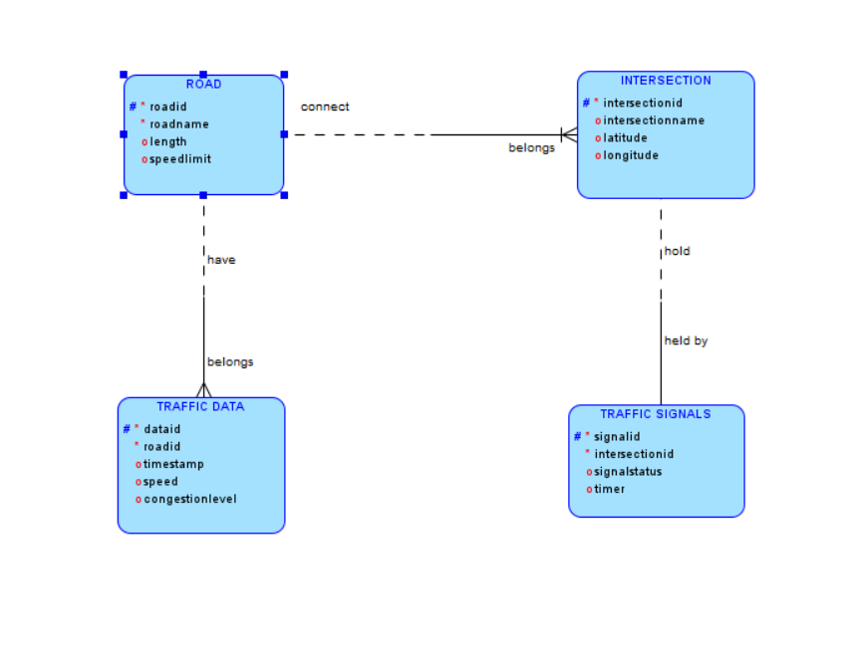

**Task 4: Justification and Normalization**

Justify your design choices, including considerations for scalability, real-time data processing, and efficient traffic management.

Discuss how you would ensure the ER diagram adheres to normalization principles (1NF, 2NF, 3NF) to minimize redundancy and improve data integrity.

**Justification**

**1)Scalability**

The design allows for the addition of more roads, intersections, traffic signals, and traffic data without affecting existing data.

**2)Real-time Data Processing**

Real-time traffic data is linked to roads, enabling efficient route optimization and traffic signal control.

**3)Efficient Traffic Management**

The relationships between roads, intersections, and traffic signals allow the system to manage and control traffic flow dynamically.

**Normalization**

**1)First Normal Form (1NF):**

All attributes contain atomic values. Each entity is well-defined with unique identifiers (primary keys).

**2)Second Normal Form (2NF):**

All non-key attributes are fully functional and dependent on the primary key. For example, RoadName, Length, and SpeedLimit depend on RoadID.

**3)Third Normal Form (3NF):**

There are no transitive dependencies. For instance, Intersection attributes depend only on IntersectionID, and Traffic Signal attributes depend only on SignalID and IntersectionID.

Entity Definitions

**Roads:** Represents the network of roads in the city.

**Intersections:** Represents the points where roads meet.

**Traffic Signals:** Represents the signals installed at intersections to regulate traffic.

**Traffic Data:** Represents real-time traffic data collected from sensors.

Relationship Descriptions

**Roads to Intersections**: Roads connect to multiple intersections.

**Intersections to Traffic Signals:** Each intersection hosts one traffic signal.

**Roads to Traffic Data:** Roads have multiple traffic data entries over time.

**Deliverables**

1. **ER Diagram**: A well-drawn ER diagram that accurately reflects the structure and relationships of the TFMS database.
2. **Entity Definitions**: Clear definitions of entities and their attributes, supporting the ER diagram.
3. **Relationship Descriptions**: Detailed descriptions of relationships with cardinality and optionality constraints.

**Justification Document**: A document explaining design choices, normalization considerations, and how the ER diagram supports TFMS functionalities